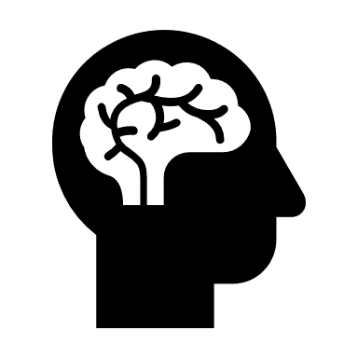Deep Learning using Neural Networks

Machine learning is a way of training machines using data and mathematical models so that they can learn to automate certain tasks without human intervention. Machine learning is a subset of artificial intelligence, and deep learning is a subset of machine learning. Building mathematical models for calculating outcomes is not new, but it gained significant momentum in the early 21st century due to big data. Industries needed predictive models that could be used to analyse enormous amounts of customer data. Since then, many real-world applications of machine learning have been developed. Machine learning has significantly transformed the fields of medical science, finance, business, environmental science, and more. Technologies in machine learning, such as neural networks, large language models, and computer vision, have emerged.

Deep learning is a field of machine learning that provides solutions by using neural networks. In this article, let’s try to understand how neural networks work. As the name suggests, the term "neural network" is adopted from the network of neurons in the human brain. It was named so because, in the beginning, neural networks were a type of model developed to mimic the function of the human brain.

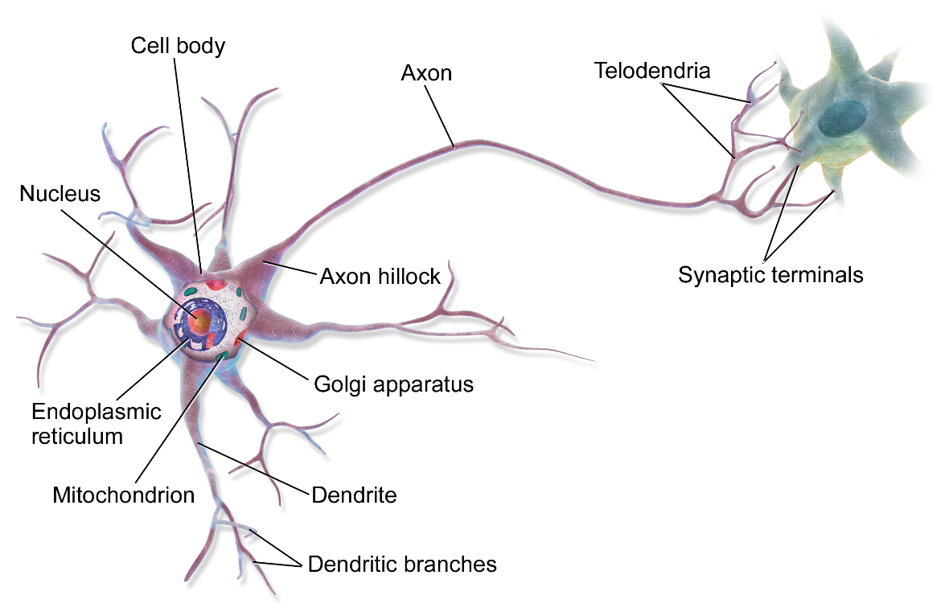

Just like biological neurons, which have multiple axons that take inputs from other neurons to process data and then generate an output signal that acts as an input to another neuron, neurons in a neural network take input from multiple neurons and generate an input signal for other neurons. Although the initial goal behind the development of neural network-based machine learning models was to mimic the human brain, it has become evident that we, as humans, don’t fully understand how the brain works. As a result, the applications of neural networks have rapidly increased to solve real-world problems rather than merely mimicking biological processes.

Before understanding how neural networks work, let’s first explore how data flows through a machine learning model to predict an outcome.

Ex) Linear Regression:

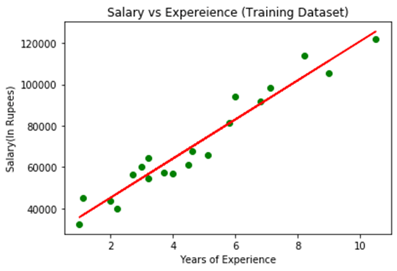

Fitting a Straight Line into the Dataset

Linear regression is a machine learning model that takes the number of features in a dataset as input and tries to fit a linear curve (straight line) through those data points using an optimization function (e.g., the gradient descent algorithm). When a new value of input is given, the output can be predicted. This is done by properly determining the weights of the different features in the given curve.

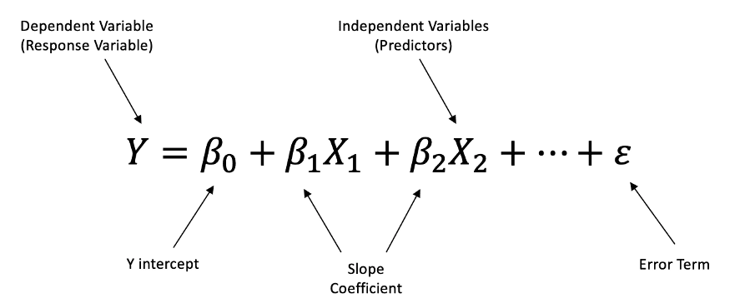

Example of Multivariable Linear Regression

Neural networks are made up of n Numbers of hidden layers consisting of M numbers of neurons where each neuron is fed with data which is evaluated using activation function (ex. Sigmoid). Activation functions are mathematical functions which generate output for each neuron also called as activation value (values on scale of 0-1). If a layer consists of m neurons, then activation values of M such neurons act as an input Vector for Other Layer in the Neural Network. The process continues till Last Layer (Output Layer) Consisting predicting the final value

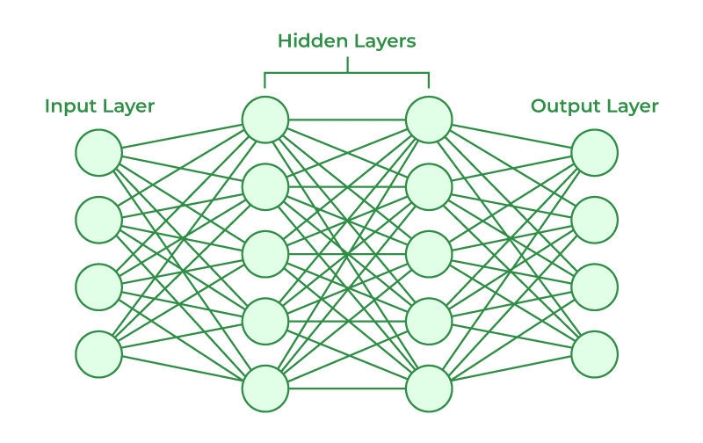

Architecture of a Neural Network 1

Neural networks are widely used in applications like image recognition, handwritten digit recognition, and more.  
What makes neural networks so special?  
Unlike linear and tree-based learning algorithms, neural networks have the capacity to process enormous amounts of data. Classical learning algorithms can’t be improved beyond a certain point by increasing the amount of data, whereas neural networks can increasingly boost the efficiency of the algorithm by using large datasets for training.

Another important feature of neural networks is their ability to perform feature engineering by themselves. To put it simply, when we train neural networks, each layer passes an activation vector to the next layer, thus acting as a feature-value input for that layer. There are many different types of architectures available for specific use cases of neural networks, which can make them work wonders!

Are neural networks computationally efficient?  
It’s true that neural networks are among the most efficient algorithms; however, as it is rightly said, everything comes at a cost, and so does training neural networks. Training neural networks is computationally very expensive, requiring both CPUs and GPUs. ChatGPT, a type of generative pretrained transformer, is trained on some of the most expensive GPUs available. Training large language models in Indian languages will require much more capital.

*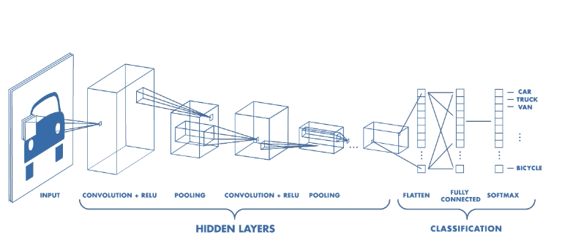*

Image Recognition